**Lab 2 – Traffic Light – Test Plan**

1. Turn the traffic light on, cycle through lights with no left turns
   1. Start with NS Green for 3 counts
      1. Count3 enabled
      2. All other counters not enabled
      3. Count3 term high sets up next state to “NS_Yellow”
   2. Transition to NS Yellow for 2 counts
      1. When the state changes:
         * Count3_en = 0
         * Count3_term = 0
         * Count2_en = 1
      2. Count2 term high sets up next state to “EW_Green”
   3. Then EW Green for 3 counts
      1. When state changes
         * Count3_en = 1
         * Count2_en = 0
         * Count2_term = 0
      2. Count3 term high sets up next state to “EW_Yellow”
   4. Then EW Yellow for 2 counts
      1. When the state changes:
         * Count3_en = 0
         * Count3_term = 0
         * Count2_en = 1
      2. Count2 term high sets up next state to “NS_Green”
   5. Then go back to NS Green

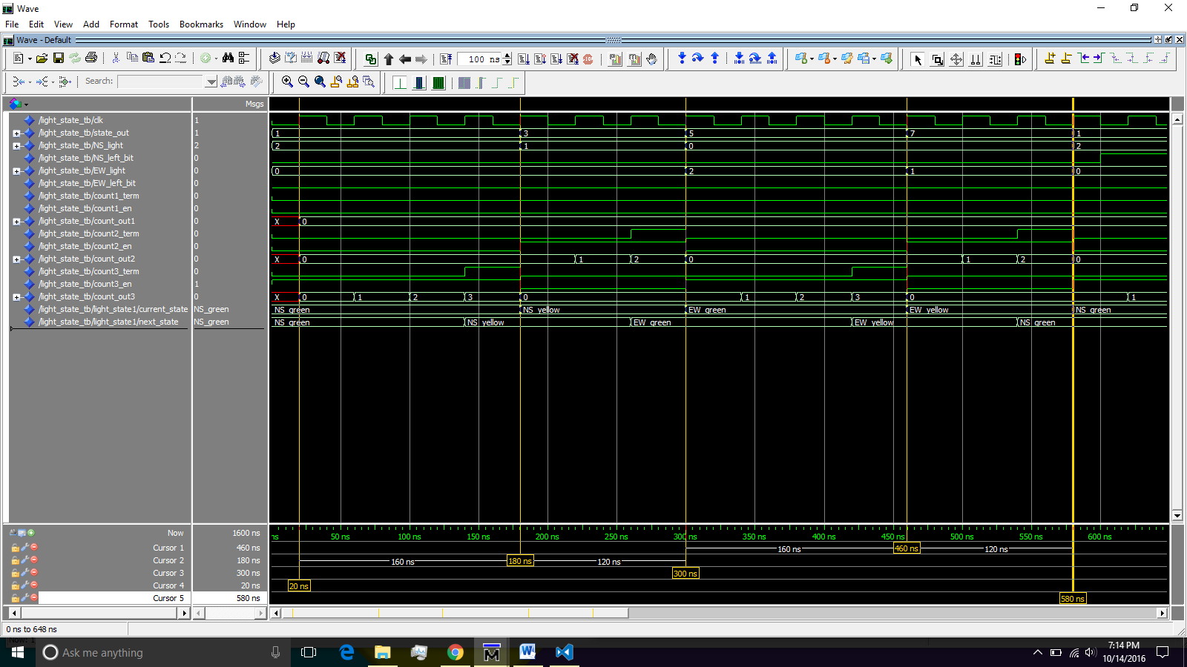

A

B

C

D

E

1. Cycle through lights with NS Left Turn bit on
   1. Start with NS Green
      1. Count3 enabled
      2. Count3 term high sets up next state to “NS_Yellow”
   2. Transition to NS Yellow for 2 counts
   3. Then EW Green for 3 counts
   4. Then EW Yellow for 2 counts
      1. When the state changes:
         * Count3_en = 0
         * Count3_term = 0
         * Count2_en = 1
      2. Count2 term high sets up next state to “NS_Left”
   5. Then NS Left for 1 count
      1. When state changes
         * Count1_en = 1
         * Count2_en = 0
         * Count2_term = 0
      2. Count1 term high sets up next state to “NS_Green_short”
   6. Then NS Green Short for 2 counts
      1. When state changes
         * Count1_en = 0
         * Count1_term = 0
         * Count2_en = 1
      2. Count1 term high sets up next state to “NS_Green_short”
   7. Then NS Yellow

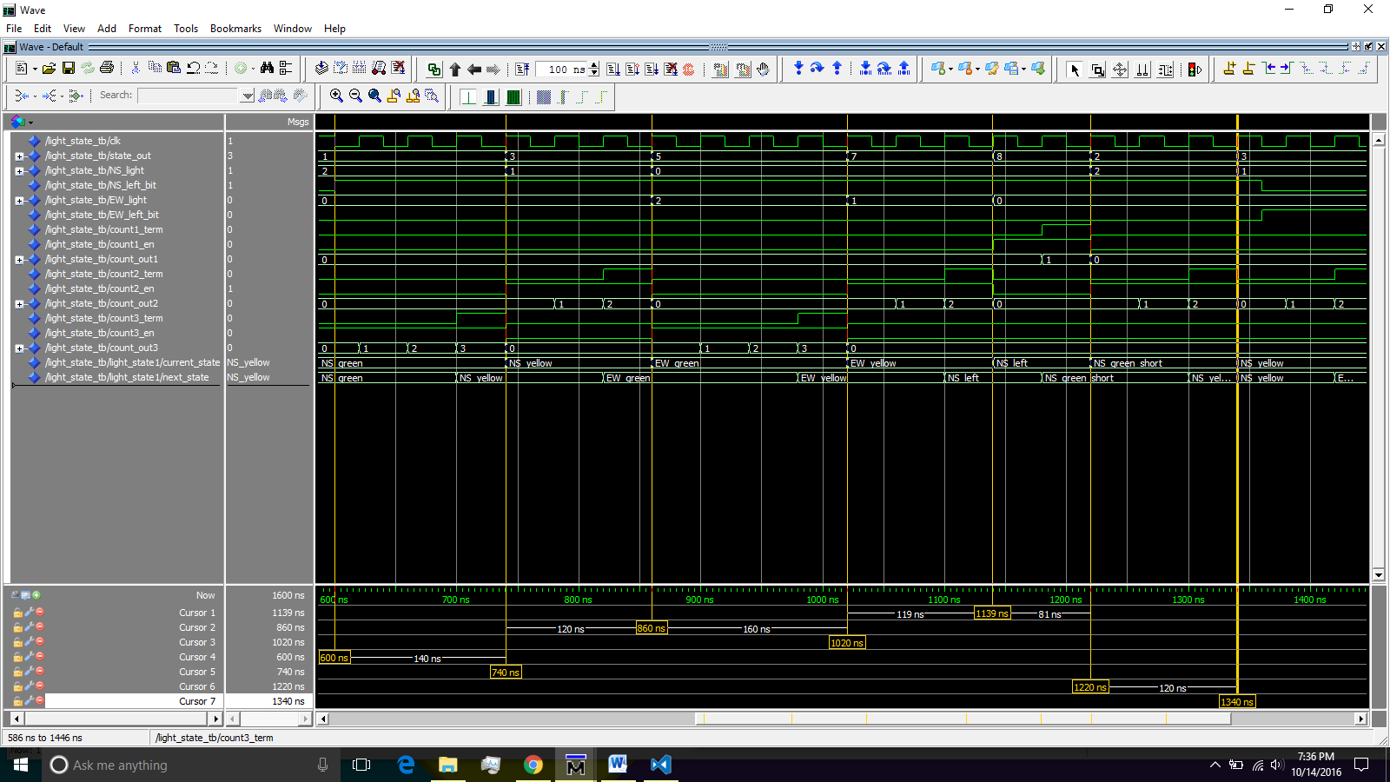

A

B

C

D

E

F

G

1. Cycle through lights with EW Left turn bit on
   1. Start at NS Yellow for 2 counts
   2. Then EW Left for 1 count
   3. Then EW Green Short for 2 counts
   4. Then EW Yellow

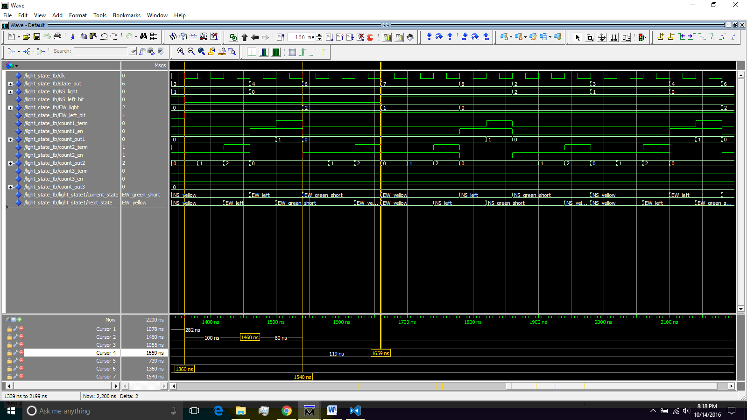

A

D

C

B

1. Cycle through lights with both directions left turn bit on
   1. Start at EW Yellow for 3 counts
   2. Then NS Left for 1 count
   3. Then NS Green Short for 2 counts
   4. Then NS Yellow for 2 counts
   5. Then EW Left for 1 count
   6. Then EW Green Short for 2 counts
   7. Then back to EW Yellow

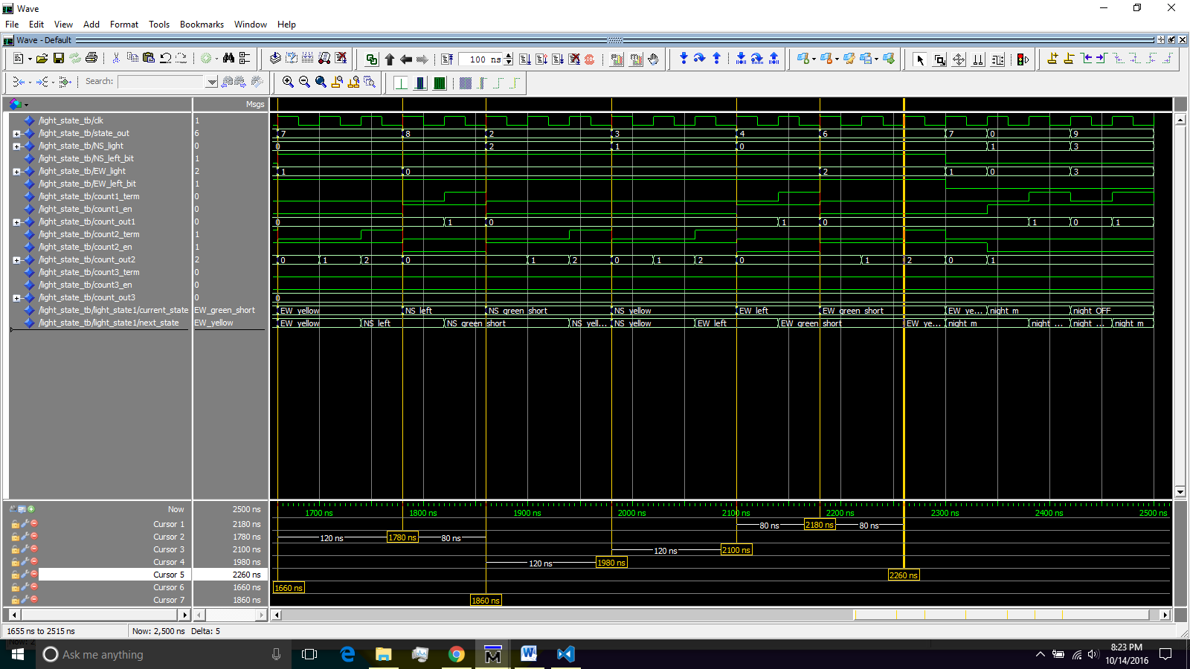

A

B

C

D

E

F

G

1. Go into night mode
   1. NS blinks Red 1 count on and 1 count off
   2. EW blinks Yellow 1 count on and 1 count off
2. Exit state mode and go back into normal operation
   1. Begin at NS Green and continue normally

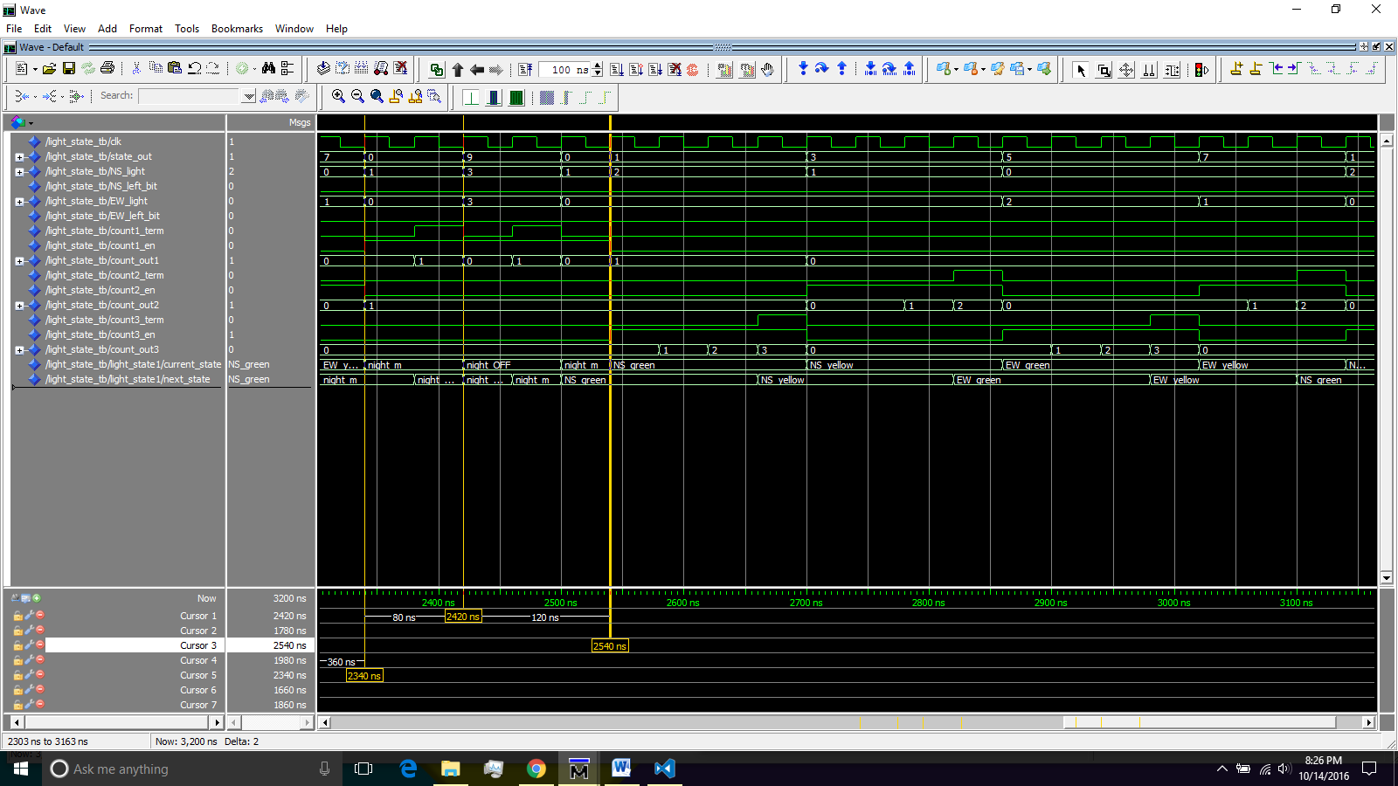

5A

5B

6A